|  |
| --- |
| Coil Technologies Pty Ltd |
| Integration of Mojaloop with ISO 8583 |
| Proof of Concept |

|  |
| --- |
| Renjith Palamattom  3-1-2019 |

Contents

Executive Summary 2

Mojaloop 2

ISO Payments Switch 4

Terminal Interfaces 5

Integration Solution 6

Transaction flow 6

ATM Initiated Cash Out 6

Transaction flow 7

Merchant-Initiated Merchant Payment Authorized on POS 8

Transaction flow 8

# Executive Summary

Coil Technologies Pty Ltd, has embarked on an initiative to integrate Interledger protocol with ISO 8583 protocol to provide seamless cross technology platform integration between legacy payment systems and cutting - edge technology trends.

As a part of this project, Coil has decided to make use of the Mojaloop system and related technologies, as a starting point to prove that such an integration between legacy and futuristic technologies would be possible. It is assumed that, it would always be better to embark on launching a new business in the EFT & Payments vertical, by integrating such systems with conventional payment systems and devices, rather than the radical replacement of an existing system, especially in a market where the payments systems are dominated and monopolized by multinational corporate establishments, using robust but dated legacy technologies.

# Mojaloop

Mojaloop is an open source software for creating digital payments platforms that connect all customers, merchants, banks, and other financial providers in a country's economy. Rather than a financial product or application in itself, Mojaloop establishes a blueprint for technology that bridges all the financial products and applications in any given market.

The basic idea behind Mojaloop is that we need to connect multiple Digital Financial Services Providers (DFSPs) together into a competitive and interoperable network in order to maximize opportunities for poor people to get access to financial services with low or no fees. We don't want a single monopoly power in control of all payments in a country, or a system that shuts out new players. It also doesn't help if there are too many isolated subnetworks.

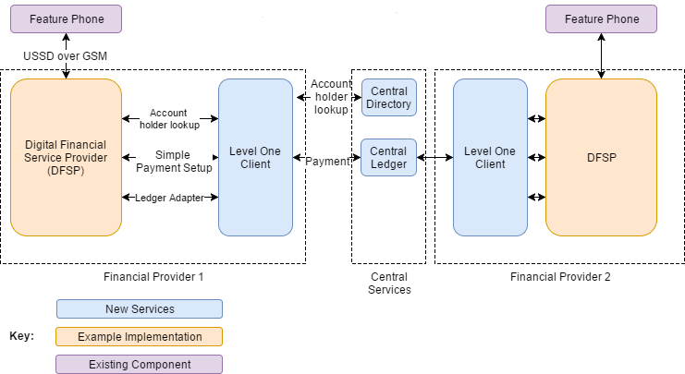

The basic idea behind Mojaloop is that we need to connect multiple Digital Financial Services Providers (DFSPs) together into a competitive and interoperable network in order to maximize opportunities for poor people to get access to financial services with low or no fees. We don't want a single monopoly power in control of all payments in a country, or a system that shuts out new players. It also doesn't help if there are too many isolated subnetworks. Our model addresses these issues in several key ways:

A set of central services provides a hub through which money can flow from one DFSP to another. This is similar to how money moves through a central bank or clearing house in developed countries. Besides a central ledger, central services can provide identity lookup, fraud management, and enforce scheme rules.

A standard set of interfaces a DFSP can implement to connect to the system, and example code that shows how to use the system. A DFSP that wants to connect up can adapt our example code or implement the standard interfaces into their own software. The goal is for it to be as straightforward as possible for a DFSP to connect to the interoperable network.

Complete working open-source implementations of both sides of the interfaces - an example DFSP that can send and receive payments and the client that an existing DFSP could host to connect to the network.

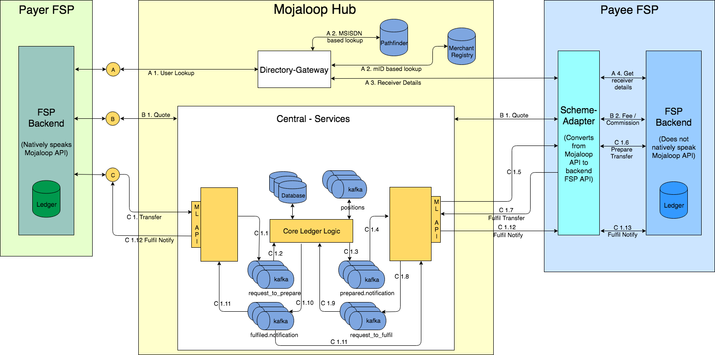

# ISO Payments Switch

A Payment Switch is Transaction processing software which receives transaction request from more than one interface (ATM, POS, mPOS, payment gateway and many more) and obtain authorization for transaction from defined hosts (Banking hosts for account authorization for debit cards or credit card hosts or prepaid card host).

A Switch is a comprehensive suite of Switching solution with capabilities to drive POS, ATM and eCommerce channels. Along with conforming to PCI/PA DSS standards, the solution is also capable of MasterCard/Visa/AMEX interfacing and processing.

The Switch is based on standard ISO 8583 and ISO JSON formats, which makes the solution ideal for a multitude of transaction channel processing including e-Commerce and mobile payments.

* A full suite of modules which can be used to process financial transactions originating from ATM, BNA, POS, MPOS, E-Commerce and Hosts
* Modular architecture
* Supports Horizontal scaling

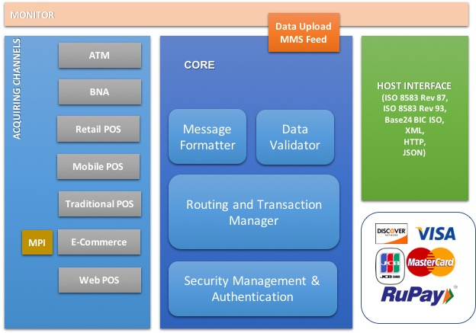

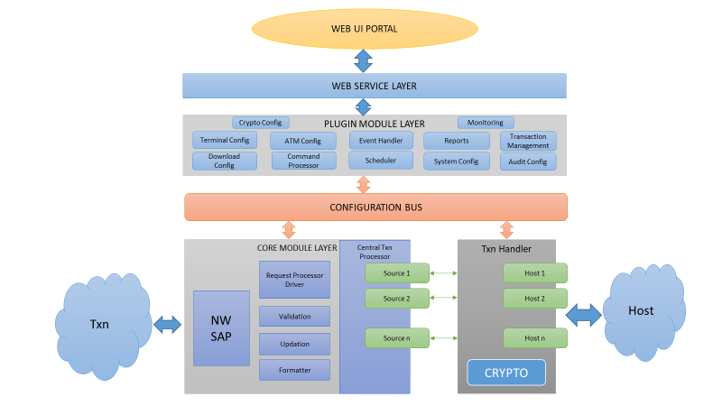

## Terminal Interfaces

Terminal Driver is an application that has been developed to drive a device that accepts and processes EFT & card-based transactions, such as ATM, Pin pads, POS, etc. and could be integrated with any type of Switch/Host /Network. It has been designed in such a way that multiple instances could be implemented by separating database, which in turn reduces downtime. This also helps to handle multiple FI’s with a single implementation without dependency or sharing of individual sensitive data. Implementation of P2PE has been done to provide extra security to the card holder.

The system also has user friendly Web based Interface for Centralized management and monitor the system/ATM/POS/device’s performance. The terminal driver/interface supports full download configuration flexibility with States, screens, languages, channels, marketing themes, etc. It also supports all standard Payments protocols such as ISO 8583/20022, ISO JSON, Base24 etc. as well is PCI/PA DSS, EMV compliant.

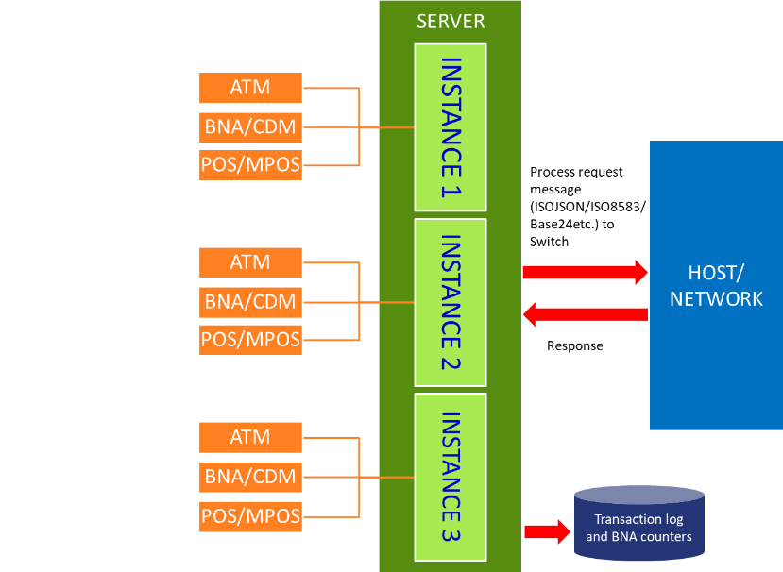

# Integration Solution

The idea of the integration solution is to make use of Mojaloop system or similar systems, as an alternative to ISO based Payment switches. Similar to what Mojaloop is to SWIFT, we are proposing a solution that would be affordable to the participants and hence accelerating the process for financial inclusion.

The proposed solution would make use of the terminal application interface to send payment transactions through to Mojaloop system, by making use of an ISO-OPEN API converter/connecter plug-in or interface, similar to the Scheme Adapter in the Mojaloop system. As the Scheme adapter performs Mojaloop API to FSP API conversion, the custom plug-in/interface would function as a protocol and message translator between the ISO interface and the ML API or the Scheme Adapter.

# Transaction flow

## ATM Initiated Cash Out

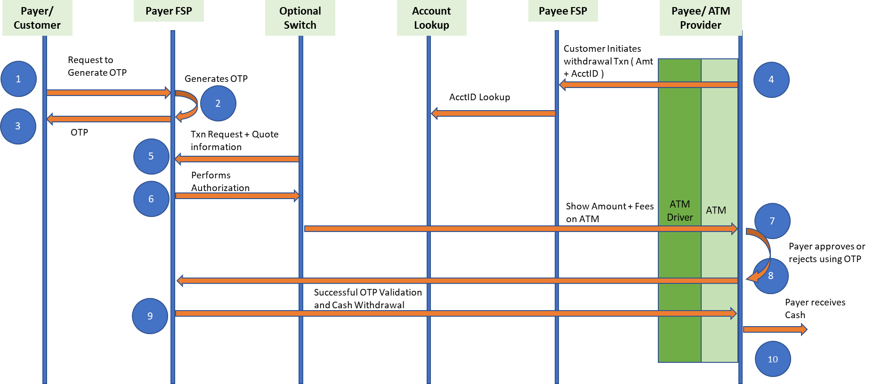

### Transaction flow

Firstly, customer will have to generate OTP through mobile application for desired ATM Initiated Cash-out amount. This OTP will be sent to customer’s mobile number.

* Customer generates an OTP before initiating the transaction request from ATM.
* The customer initiates withdrawal transaction on the ATM by entering their account ID and amount.
* Cash Out Request will be generated by ATM Driver in NDC protocol. This will be converted to OPEN API call and will be sent to Mojaloop.
* Mojaloop will perform Account lookup and the transaction request will be sent to Payer FSP for authentication.
* The Payer FSP validates the transaction request and also calculate the Quote for the transaction.
* The calculated Quote will be displayed on the Terminal for confirmation by the Payee.
* The Customer will authenticate the transaction by entering pre-generated OTP.
* Payer FSP will authenticate the OTP.
  + If successful, the customer’s account will be debited, and the ATM account maintained by Payee FSP will be credited.
* Payer FSP will send response back to Mojaloop.
* Response will be received by ATM Driver in OPEN API. This will be converted to ISO and is sent to ATM.
* ATM will perform the actions as mentioned by the message. (Dispense and Print etc.)

## Merchant-Initiated Merchant Payment Authorized on POS

## 

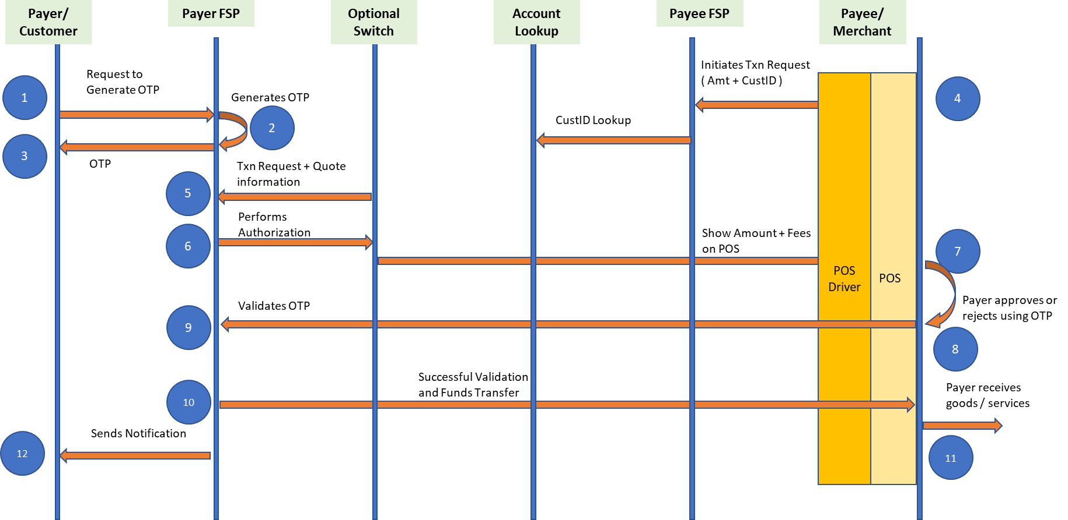

## Transaction flow

* Customer requests for an OTP ( pre-generate OTP using mobile app/CMS)
* Merchant will initiate payment for the desired amount and Customer ID through POS device.
* The request will be converted from ISO to OPEN API and will be sent to Mojaloop. From there account lookup will be done and the request will be send to Payer FSP for authorization.
* The Payer FSP validates the transaction request and also calculate the Quote for the transaction.
* The calculated Quote will be displayed on the Terminal for confirmation by the Payee.
* The Payer FSP will authorize the transaction with dynamic OTP (or QR Code) which is generated through mobile application and entered by the customer.
* If Payer FSP authorizes the transaction, funds will be sent to Merchant (Payee) FSP. If Payer FSP declines, the transaction will be aborted.
* Response will be sent back to POS driver through Mojaloop in OPEN API. It will be converted to ISO(POS) and will send the response to POS.
* Notification will be sent to Payer and Payee from respective FSP’s.